IT Governance 61675
Course Project - Week 8
Problem Definition & Solution Design: Implementation Plan: Zelle
By: DeShaun Riddick
Email: driddick@my.keller.edu
DeVry University
Course Number: SEC592
Professor: Robert Krell
Date: 04/26/2025

Contents
Executive Summary 3
Problem Definition 4
Who's Impacted & What's the Problem 4
What's Happening Due to the Problem 4
Remedy 5
Solution Design Overview 6
Solution Design 6
Supporting Information (Events, Breaches, Crimes, Regulations) 7
Presentation of the Issues Discovered 8
Implementation Overview 10
Required resources and new updated policies 12
Establish Teams 13

Executive Summary

Zelle, an electronic funds transfer platform co-owned by JP Morgan Chase, Bank of America, and Wells Fargo, was launched quickly in response to rising competition from Venmo and Cash App. However, this urgency came at significant cost-security vulnerabilities. The application has been a repeated target of fraud, causing nearly $870 million in consumer losses and drawing regulatory scrutiny.
The primary issues stem from poor cybersecurity practices, weak governance, and lack of
standardized protections for end users. Consumers fell victim to phishing scams and
credential theft, and banks often failed to take accountability for reimbursement.
To address these challenges, this report proposes an implementation plan utilizing the COBIT19 IT Governance Framework in conjunction with ISO/IEC 27001 standards. Partnering with Scarlet| Cybersecurity, Zelle will integrate a managed SIEM system, robust Multi-Factor Authentication, Zero Trust Architecture, and continuous penetration testing.
The project has a set timeline of 1-2 months, a proposed annual budget of $1.5 million, and
the involvement of in-house IT staff and external white-hat auditors. The implementation
plan includes updated policies, ongoing training, and structured identity lifecycle
management to ensure long-term security and compliance.

Problem Definition
Zelle, formerly known as ClearXchange is a privately held company founded in 2016. They are an electronic funds transfer service provider. Zelle is owned by 3 major banks, JP Morgan Chase, Bank of America and Wells Fargo. As the creation of Zelle came to fruition, the 3 banking conglomerates precariously became negligent of improperly providing safeguards for the end users. According to the (Consumer Financial Protection Bureau) CFPB, Zelle was “rushed to market” out of fear against competitors such as Venmo and Cash app who were gaining notoriety quickly (CFPB Newsroom, 2024).

Who's Impacted & What's the Problem
Zelle lacked cybersecurity so severely that users suffered repeat offenses by the same criminals. Zelle developers left the application open to exploits. Consumers felt the financial drain totaling a whopping $870 million defaulted from their accounts. Furthermore, to add insults to injury, the banks failed to properly investigate the consumers’ complaints and often put the blame on the end user. A reason for this attitude against the customer according to USA today, “banks have argued that covering the cost of scams will encourage more fraud and potentially cost billions of dollars” (Shekhawat, 2024).

What's Happening Due to the Problem
The consumers who use Zelle are receiving fake E-Mails that ask them to provide sensitive information. Threat actors are engineering E-Mails that look to attain credentials by way of theft. Users have been urged to click suspicious links with a sense of urgency because of a password reset request. These links lead to fake landing pages designed to look like Zelle’s password recovery page. If a user does enter their credentials, the attacker now can take the credentials and use them on the real account to commit fraudulent acts.

Remedy
Implementing COBIT19 framework can ameliorate the gaps and low hanging fruit for management and IT Governance. First there needs to be a meeting with the stakeholders. Prioritizing a well thought out strategy that aligns with the enterprise's goals, management, and governance objectives will improve how the application is managed. A holistic approach using COBIT19 needs to take place throughout all three of the banking systems. Information must be streamlined so communication of fraudulent activity is shared with all 3 banks to alert about potential threats. Using performative actionable milestone markers to monitor the success of the change is key. COBIT19 objectives will allow organizations to create comprehensive and bespoke IT strategies as they continue to reverse troubled legal waters as per (Good e-Learning, 2024).
Cobit19 Management Objectives: BAI06-Manage IT Changes is a great way to add a business process, applications and infrastructure that will improve the company. ISO/IEC 27001 promotes a holistic approach to information security: vetting people, policies and technology. An information security management system implemented according to this standard is a tool (ISO/IEC 27001:2022, n.d.). As the framework begins to take shape, the deliverables, procedures, regulations, processes and service will effectively solve the IT Governance problem of ID Fraud.

Solution Design Overview
The chosen approach is to implement COBIT 19 for IT governance and ISO/IEC 27001 for
security controls. This design promotes a holistic structure to ensure security, compliance,
and data integrity, with special emphasis on identity and access management, incident
response, and continuous monitoring.

Solution Design
The Solution Design of choice is COBIT 19 framework. After consulting with Scarlet|Cybersecurity for help with gaining insight on using Zelle in a financial institution, the realization of policy customization became a necessity. Using high-level architecture for identity and access management systems will be customized into policy known as ARM. User registration will create the profile for access. The credentials issuance and management are important to Zelle and the financial institution. Life-cycle management of credentials prevents rogue employees from creating internal threats.
Access rights management policy is how to have a layer of protection from bad actors provisioning bad requests. MFA (Multi-Factor Authentication) will establish confidence in the user’s identity. A strong access control policy will be the formidable structure to allow users to continue an action request or have it denied. No write up or write down is advised. Regular audits of records of attempts by a digital identity and the changes made to such an identity. The Zero Trust Privileged Access Management is strong in Validating all users, devices and network before access is granted instead of automatically trusting said users by default.

As a standard operating procedure (SOP) the policy is not meant to be a static document, but a living document. Monitoring the financial institution for adherence to best practices, ensuring consistency and efficiency will improve with employee training and KDB (Knowledge Database) for in depth explanation of a SOP on MFA Access Controls, and Zero Trust. Monitoring the network traffic for anomalies and reporting are automated by a managed SIEM (Security Information and Event Monitoring).
As a simple cybersecurity solution to deploy a new SLA (Service Level Agreement) from a managed cloud SIEM to offset the unexpected activities because Hackers don’t always use software and automated processes to attack a private IT system. They also have manual methods for exploiting networks and endpoints (Cooper & Cooper, 2025b). The cost of not deploying a $10,000.00 SIEM outweighs the financial duty to protect the customers’ financial integrity, confidentiality and availability within Zelle.

Supporting Information (Events, Breaches, Crimes, Regulations)

. Consumer Financial Protection Bureau (2024): Investigated Zelle's parent banks for failure to
investigate complaints and prevent fraud.
. USA Today Report: Banks refused to reimburse users, citing "user fault" to avoid setting a fraud-
reimbursement precedent.
. $870 Million in losses: Reported from user fraud incidents on Zelle (2024).
. ISO/IEC 27001 Standards: Not followed in original implementation.
. COBIT 19 Framework: Not adopted, leading to poor governance structure.
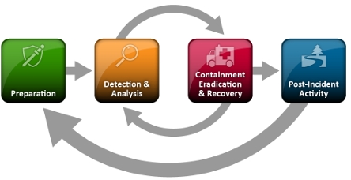

Presentation of the Issues Discovered

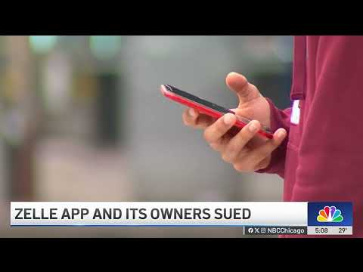
The likelihood of another security breach is high. This is due to the evolving landscape of threat actors who change their attack methods constantly. What the company cannot tolerate is another class action lawsuit and reputational damage that impacts the business
After consulting with Scarlet| cybersecurity, the implementation design shouldn’t take longer than 1 to 2 months. The consultation cost initially was $300/Hr. Once onboarded, and the newly designed infrastructure is rolled out, the auditors will do an assessment. White hackers will perform penetration tests upon NDA agreement. The overall annual budget set aside is estimated at $1.5 million.
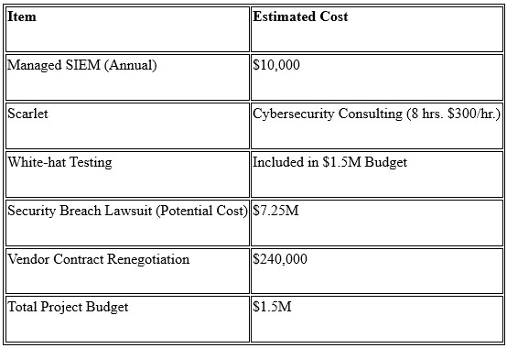

Implementation Overview
The implementation overview is to canvas what the three financial banks need, and it is requisite of them to measure success and the security posture overhaul. contributors to the success of the programme will come from scarlet cybersecurity they will provide the risk analysis and debrief of their findings. From here the objectives can be identified as the information continues to inbound. Zelle has on boarded Scarlet to spearhead implementing the required resources for the Security Information and Event Management system solutions. The service level agreement with Scarlet to provide A managed SIEM for Zelle, and the financial institutions, JP Morgan Chase, Wells Fargo, and Bank of America, align with the stakeholder's fiduciary responsibilities to the budget.
Scheduling for the deliverables to be met has been challenging to say the least. As we do not have budget for hiring contractors other than Scarlet who was picked up as a consultant and offered to provide service for all three institutions to support Zelle, so we did not have to purchase a SIEM, as they are quite expensive. The IT Department that is inhouse will take care of providing workshops for the financial institutions on best practises when it comes to recognising threats whether it be phishing, vishing, smishing, and whaleling. Multi-Factor Authentication is a second layer of security to mitigate fraudulent activity.
Auditors are needed to assess the organization security posture and (SOP) Standard Operating Procedures. Out of the finding of any possible attack vectors, patching can be recommended. This team can recover the vulnerabilities and provide the necessary improvements. A budget for white ethical hackers has been set aside for continual quarterly assessment. A thorough form the foundation off the cybersecurity plan allows effort to take priority (Bhansali, 2024). 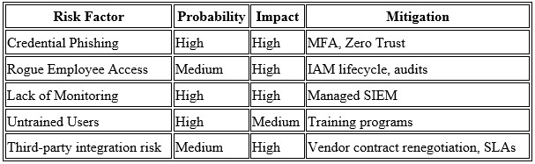
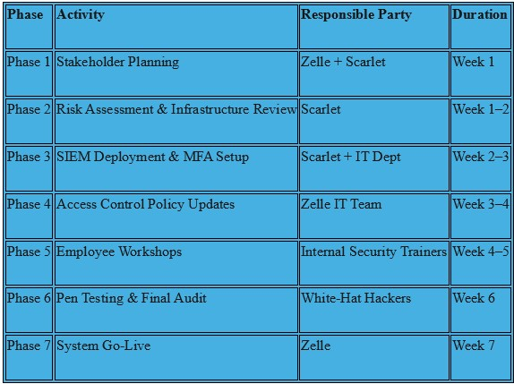

Required resources and new updated policies

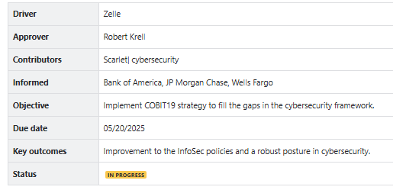

Track Progress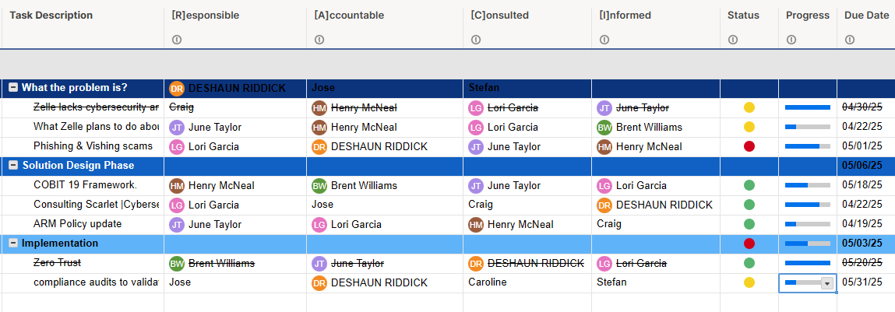

Establish Teams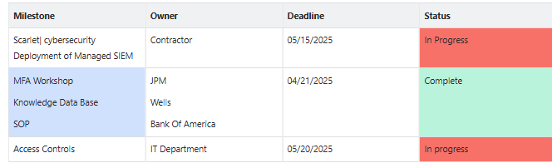
Allocate Resources
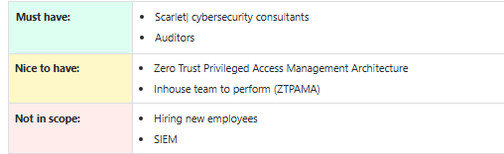

References
Early Warning Services, LLC; Bank of America, N.A.; JPMorgan Chase Bank, N.A.; Wells Fargo
Bank, N.A | Consumer Financial Protection Bureau. (2024, December 20). Consumer Financial ProtectionBureau.https://www.consumerfinance.gov/enforcement/actions/early-warning-services-llc-bank-of-america-na-jpmorgan-chase-bank-na-wells-fargo-bank-na/
Good e-Learning. (2024, April 10). What is COBIT 2019? Everything you need to know -goode
Learning. https://goodelearning.com/articles/what-is-cobit-2019/
Shekhawat, J. S. (2024, August 9). Bank of America, Wells Fargo are under investigation for
handling of customers funds on Zelle. USA TODAY. https://www.usatoday.com/story/money/2024/08/07/major-banks-under-investigation-zelle-transactions/74704325007/
Cooper, S., & Cooper, S. (2025, February 20). The best managed SIEM services. Comparitech. https://www.comparitech.com/net-admin/managed-siem-services/
Shea, S. (2024, February 5). SOAR (security orchestration, automation and response). Search Security. https://www.techtarget.com/searchsecurity/definition/SOAR

Bhansali, A. (2024, December 13). How to develop and implement a cybersecurity Plan. OmniDefend. https://www.omnidefend.com/how-to-develop-and-implement-a-cybersecurity-plan/
https://www.youtube.com/watch?v=nWpb6UtzozE
https://www.youtube.com/watch?v=nWpb6UtzozE

